Ale Barm Bread with Spent Grains
Lady Ursula de Strattone, Barony of Arn Hold
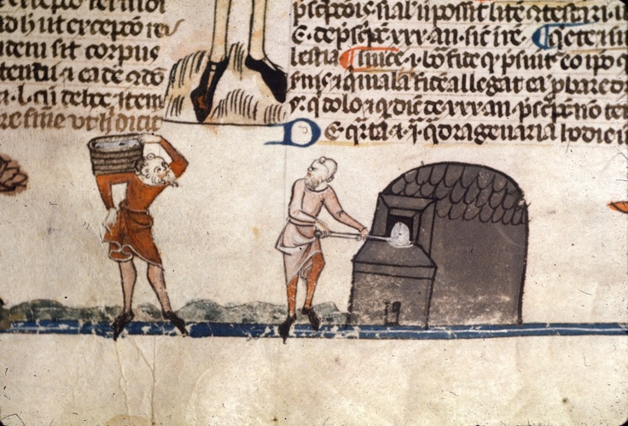
Smithfield Decretals, Late 13th c. Royal 20 E IV f. 145v
Development/inspiration/period source:
Bread is one of the oldest and known foods, and has been recorded in archaeological finds and written records going back for millennia: "Mesopotamian food is known from archaeology and written records on cuneiform tablets, including bilingual Sumerian-Akkadian word lists. These sources indicate the importance of barley bread, of which many kinds are named, and barley and wheat cakes.¹”
Bread was a very large part of the medieval diet, with most people of all classes eating 2-3 pounds of bread per day². St. Augustine even used the bread of the Eucharist as an analogy to discuss the state of a man’s soul: “This bread retells your history… you were brought to the threshing floor of the Lord and were threshed…While awaiting catechism, you were like the grain kept in the granary… At the baptismal font you were kneaded into a single dough. In the oven of the Holy Ghost you were baked into God’s true bread.³”
While many sources⁴ tell us of the fine white loaves of white flour eaten by nobles, this is in sharp contrast to the bread eaten by common folk. Where economy and nutrition is the goal, a loaf of the cheaper and more readily-available barley, even than that already used in brewing, would provide significantly better fare for the cost.
In the middle ages, a large amount of the grain produced went to producing beer. The labor required to malt barley is considerable, and after the malted grain was soaked to obtain the wort needed for brewing, there was still valuable nutrition left in the spent grains. While I have been unable to find sources for what was done with this grain, I find it unlikely that it was thrown away. While it could have been fed to livestock, my guess is that the sweet and flavorful malted grains were probably used in cooking various cakes, breads, and porridges. I have eaten spent grain still warm from brewing, and it is truly delicious.
The other product necessary to both brewing and baking bread is yeast. There is considerable debate about which came first, beer or bread, but either way the ingredients remain the same: yeast, grain, water. There is wild yeast in nearly every environment in the world, and this wild yeast would have been the source for the earliest beer fermentations. At the end of the brewing process, when the beer is decanted into bottles or tankards, a large amount of yeast, known in period as ale barm, remains at the bottom of the barrel⁵, consisting of the yeast cells, both living and dead, as well as particulates from the brewing process. It would have been quite easy to scoop up this doughy barm and store it for use in baking, which is exactly what I have done, treating and feeding it like a sourdough starter.
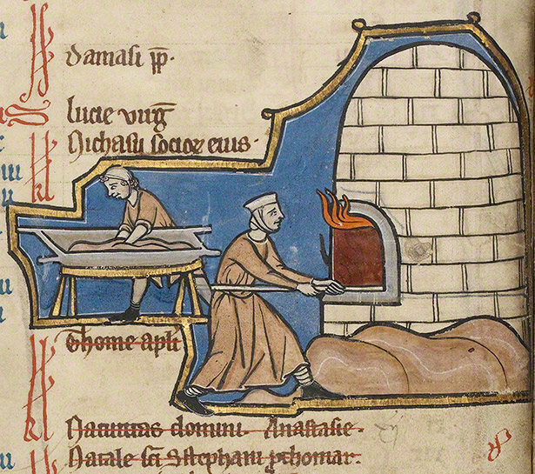
J. Paul Getty Museum, Ms. 14 fol. 8v, mid-13th c.
Peasants in period would often cook bread in a communal oven or buy bread from a local cook shop or bakery. The wood-fired clay ovens of the period would be fired, filled with the day’s many loaves, and then closed up to cook, creating a hot (usually over 500 degrees Fahrenheit), humid environment. This results in bread with a crusty and crisp exterior but a moist, chewy interior, the holy grail of many bakers.
My process
Tools used:
Standard electric oven
Glass cooking bowl
Wooden spoon
Cast iron stew pot with lid
Materials used
Unbleached wheat flour
Spent malted barley from beer brewing
Ale barm
Water
Salt
Butter
Process
The ale barm, harvested from a batch of beer made by my husband, was placed in a warm place and fed equal parts flour and water to encourage the yeast to become active. After about an hour the barm was foamy and fragrant.
To make the sponge, a cup of ale barm was mixed with two cups of flour and a cup of lukewarm water. The sponge was then left in a warm place for several more hours (approximately two). This further encourages the yeast to become active and release more esters, contributing to the flavor of the bread.
The dough was made from the sponge, with the addition of two teaspoons of salt, two tablespoons of melted butter, half a cup of the spent grains, and just enough flour to make the dough easy to work, approximately half a cup. Because I prefer “rustic” bread with large air bubbles and a more chewy texture, I kneaded the dough just enough to mix it thoroughly.
The dough was left to rise on a well-floured surface, sprinkled with flour, and covered with a towel for approximately an hour. This is a far shorter rise time than is needed on the more standard dense breads, but works well to achieve the texture I like.
To recreate the conditions of a wood-fired oven, with high temperature, radiant heat on all sides, and a humid environment, I heated my oven as hot as it will go (550 degrees Fahrenheit) and placed the cast iron pot and lid inside to heat with the oven. Once the oven was hot, I removed the pot, and carefully placed the dough inside it. I then replaced the lid and baked for about 20 minutes. I then removed the lid, to simulate the gradually escaping steam of the clay oven, and let the bread cook for a further ten minutes.
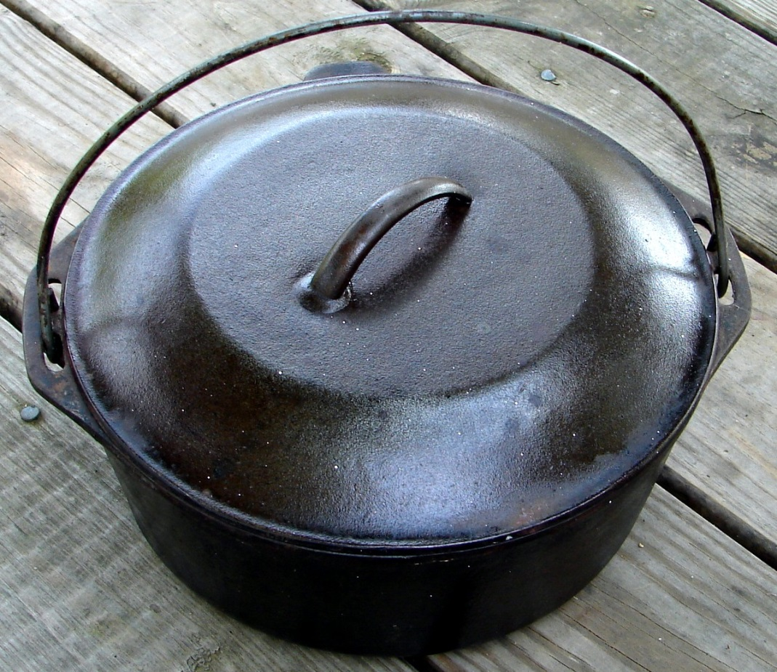
The cast iron pot used for baking.
The bread was then cooled on a cooling rack.
Final thoughts/future experiments/what I’d do differently
This recipe is one I have perfected over many years of experimentation and regular baking. The decision to try using spent grains and ale barm was one I undertook simply out of curiosity, with no notion of possible parallels with medieval baking. I can honestly say I wouldn’t change a thing about my recipe.
In the future I would like to try baking in a wood fired clay oven, and perhaps even building one myself. I have used this technique with good results on my propane barbecue, so I may try the addition of some wood chips to see if it impacts the flavor of the bread.
I would also like to try using some medieval bread recipes, though these are few and far between, since baking bread was a skill that was so universal it wasn’t necessary to record the process. I did find recipes for various flat breads, griddle cakes, and even horse bread, and I plan to experiment with these in the future.

