Elderberry Cordial
Ursula de Strattone

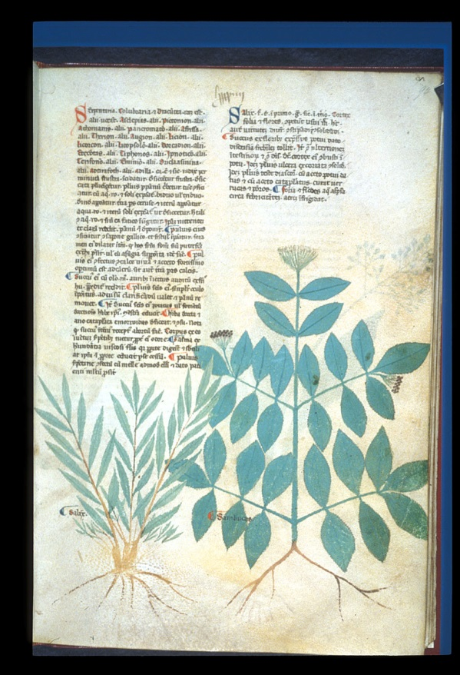
Miniature of a sambucus, or elder plant (on right). From Tractatus de herbis; De Simplici Medicina; Circa Instans; Antidotarium Nicolai by Bartholomaei Mini de Senis, c. 1280-1310, Salerno, Italy

Tools used:
Half-gallon glass jar
Cheesecloth for straining
Wooden spoon
Ingredients used:
Vodka
White Sugar
Elderberries

History:
Cordials as we know them today, sweetened and flavored beverages with a distilled alcohol base, are difficult to document in the middle ages. Martha Washington’s Booke of Cookery documents some cordial recipes which may date back to approximately 1550, but its historicity is debatable. There are recipes for medicinal liqueurs in the medieval period, but most of these do not seem to explicitly call for sugar, and do not seem to be created to be consumed or pleasure.
Distilled alcohols were commonly known in the medieval period, and alcohol was being distilled at the School of Salerno in the twelfth century. Brandy made from distilled wine is mentioned frequently in medieval sources. There are modern vodkas that claim to have origins in the medieval period, such as the Polish vodka Zubrowka, but the only primary sources for the use of distilled grain alcohol in the middle ages that I could find refer to Irish whisky, encountered by the Normans upon their invasion of the British Isles.
Cane sugar was available in the middle ages. Sugarcane, native to southern Asia, was being processed into sugar between the 7th and 4th century BCE. Carole Rawcliffe’s book Medicine & Society in Later Medieval England(1995) states “The use of sugar in pharmacy had been pioneered by the Arabs, who were thus able to extend the Greek pharmacopoeia by mixing different combinations of herbs, spices and animal products with a sweet-tasting powder or syrup base” ( pg. 5). The Oxford English Dictionary lists the first use of the word sugar in English as being used in 1299. Sugar is also mentioned in Chaucer’s “Squire’s Tale.”
Sambucus nigra, the elder tree, has a long history of being used medicinally. All parts of the plant save the fruits and blossoms are mildly toxic until cooked, and it has been associated with anti-parasitic, diuretic, antiseptic, and insect repelling properties, as well as folktales about repelling evil and communing with the otherworld. It is mentioned in several passages in The Leechbook of Bald, dated to the mid-tenth century, probably composed in Worcester under the influence of Alfred the Great. It is remarkable in that it refers to British plants and traditional remedies as well as the Latin and Mediterranean medical traditions that were widely known in this era. Leechbook III, lxiii states

Give him this for healing .
carline thistle . sedge . fane netherward .
yew berry . lupin . helenium . marsh-
mallow blossom . fen mint . dill . lily .
cockspur grass . pennyroyal . horehound . dock .
elder . lesser centaury . wormwood . strawberry
leaves . comfrey …

Process:
I harvested the elderberries for my cordial from wild elderberry bushes. This is a common wild plant in much of the northern hemisphere and would have been readily available to people of various social standing in the middle ages. Elderberries grow in large clusters, and can be quickly harvested by picking the entire cluster off of the plant, stem and all. It is important to remove the stems from the berries, as elder bark is poisonous and contains small amounts of cyanide. In order to do this, I put the whole berry clusters into my freezer. The berries are easier to remove without being crushed beyond usability this way. In the middle ages, there probably would have been few berries left by the time of the first frost, so likely they either lived with the stems and the purple fingers, or enjoyed the medicinal/purgative effects of consuming the chemicals found in the stems and bark.
The berries, approximately four cups, were placed in a half-gallon glass jar, and about a cup of sugar was added to them. The jar was filled with vodka and allowed to rest in a dark cupboard for approximately three months. I used cheesecloth to filter the berries out of the liqueur (I’ll save them for use in a future dessert). The liqueur was then tasted and additional sugar added to get a pleasant sweetness level (approximately another half cup).

What I learned:
Making liqueurs would be a fairly easy way to preserve fruit for consumption out of season. Though it seems strange to consider something like liqueur as a health food, elderberries are high in vitamin C and antioxidants, so there would be some benefits to partaking in this liqueur. Modern research has shown that elderberries possess some antiviral properties as well.
I was surprised to learn about just how available white sugar was during the medieval period. I had thought it was a far more modern item, and it certainly makes the cordial more pleasant to drink, as elderberries can taste rather tart and bitter, and hard alcohol can also be rather abrasive on its own.
For future projects I would like to try something more historically documentable. Though grain alcohol, sugar, elderberries, and liqueurs are mentioned in historical sources, I was unable to find a source for an elderberry liqueur specifically. For future projects I would like to use a more historically accurate alcohol, such as brandy, and to try an actual historical recipe. That said, many of the recipes from the middle ages do not sound like something I would enjoy tasting, but the elderberry liqueur is delicious and drinkable.

British Library listing Egerton 747 f. 94 accessed at http://www.bl.uk/catalogues/illuminatedmanuscripts/ILLUMIN.ASP?Size=mid&IllID=10085
Forbes, Robert J. A Short History of the Art of Distillation, 1970.
Gwyntarian Tunners Guild website at http://web.raex.com/~obsidian/IGGcord.html
Accessed online at https://machias.edu/faculty/necastro/chaucer/translation/ct/12sqt.html
Translated from the Old English and quoted at http://wyrtig.com/GrowingHeirloomPlants/SambucusNigraMedieval.htm

